Software Requirements Specification
for
RetailFlow – Inventory & Sales Management System
Prepared by Alex Turner, Sophia Nguyen, Rahul Verma
Organization: NovaEdge Solutions
Date Created: 02/09/2026

Table of Contents
1. Introduction
1.1 Purpose
1.2 Scope of the System
1.3 Definitions, Acronyms, and Abbreviations
2. Overall Description
2.1 Product Perspective (System Context Diagram)
2.2 Product Functions
2.3 User Classes and Characteristics
2.4 Operating Environment
2.5 Design and Implementation Constraints
3. System Architecture (Architecture Diagram)
4. Functional Requirements (Use Case Diagram)
5. User Workflow (Workflow Diagram)
6. Non-Functional Requirements
7. Security Requirements (Security Flow Diagram)
8. Data Requirements (Entity Relationship Diagram)
9. External Interface Requirements
9.1 User Interface
9.2 Application Programming Interfaces
10. Assumptions and Dependencies
11. Future Enhancements
In Microsoft Word you can insert an automatic TOC (References → Table of Contents) for page numbers.

1. Introduction

1.1 Purpose
Small and medium-sized retail businesses struggle to track inventory levels, sales performance, and stock replenishment in real time. Manual tracking and disconnected tools often lead to stockouts, overstocking, revenue loss, and poor decision-making. This system aims to centralize inventory, sales data, and reporting into a single, easy-to-use digital platform.

1.2 Scope of the System
The system provides a centralized platform for core business operations with secure access, reporting, and monitoring. Features outside the specified requirements are excluded from this version.

Included in scope:
- User authentication and authorization
- Product and inventory management
- Sales transaction tracking
- Low-stock alerts and notifications
- Supplier management
- Role-based dashboards
- Daily
- weekly
- and monthly sales reports
- Data export (CSV/PDF)
- System settings and configuration

1.3 Definitions, Acronyms, and Abbreviations
- SRS – Software Requirements Specification
- RBAC – Role-Based Access Control
- CRUD – Create, Read, Update, Delete
- UI – User Interface
- API – Application Programming Interface

1.4 Document Conventions
- IEEE 830-1998 style

2. Overall Description

2.1 Product Perspective
Web Application in the Retail / Inventory Management / Business Operations domain. Small and medium-sized retail businesses struggle to track inventory levels, sales performance, and stock replenishment in real time. Manual tracking and disconnected tools often lead to stockouts, overstocking, revenue loss, and poor decision-making. This system aims to centralize inventory, sales data, and reporting into a single, easy-to-use digital platform.
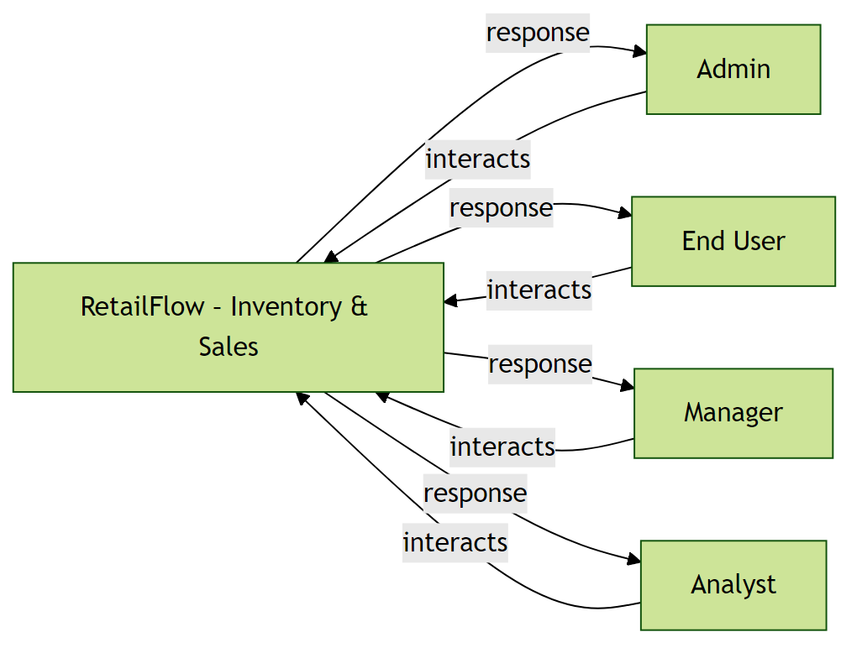

The System Context Diagram illustrating interactions between the system and external entities has been included above.

2.2 Product Features
- User authentication and authorization
- Product and inventory management
- Sales transaction tracking
- Low-stock alerts and notifications
- Supplier management
- Role-based dashboards
- Daily
- weekly
- and monthly sales reports
- Data export (CSV/PDF)
- System settings and configuration

2.3 User Classes and Characteristics

Admin

End User

Manager

Analyst

2.4 Operating Environment
- Standard web/server environment

2.5 Design and Implementation Constraints

2.6 User Documentation
- User manual to be provided

2.7 Assumptions and Dependencies

3. System Architecture
The system follows a layered architecture consisting of: Presentation Layer (Web UI), Application Layer (Backend services), Data Layer (Database), and External Integration Layer (APIs, third-party services).
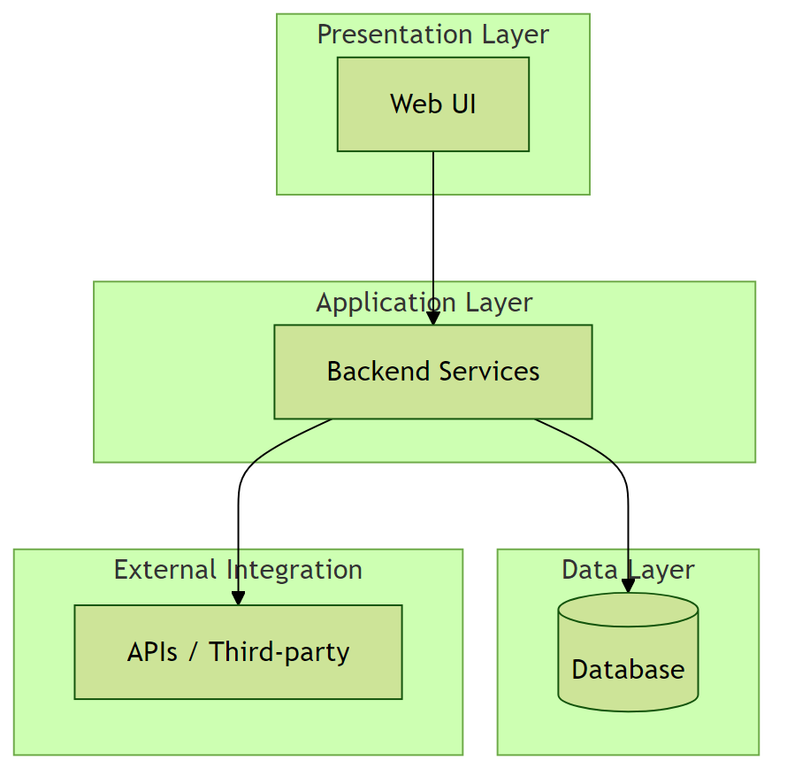

The System Architecture Diagram showing component interactions has been included above.

4. Functional Requirements
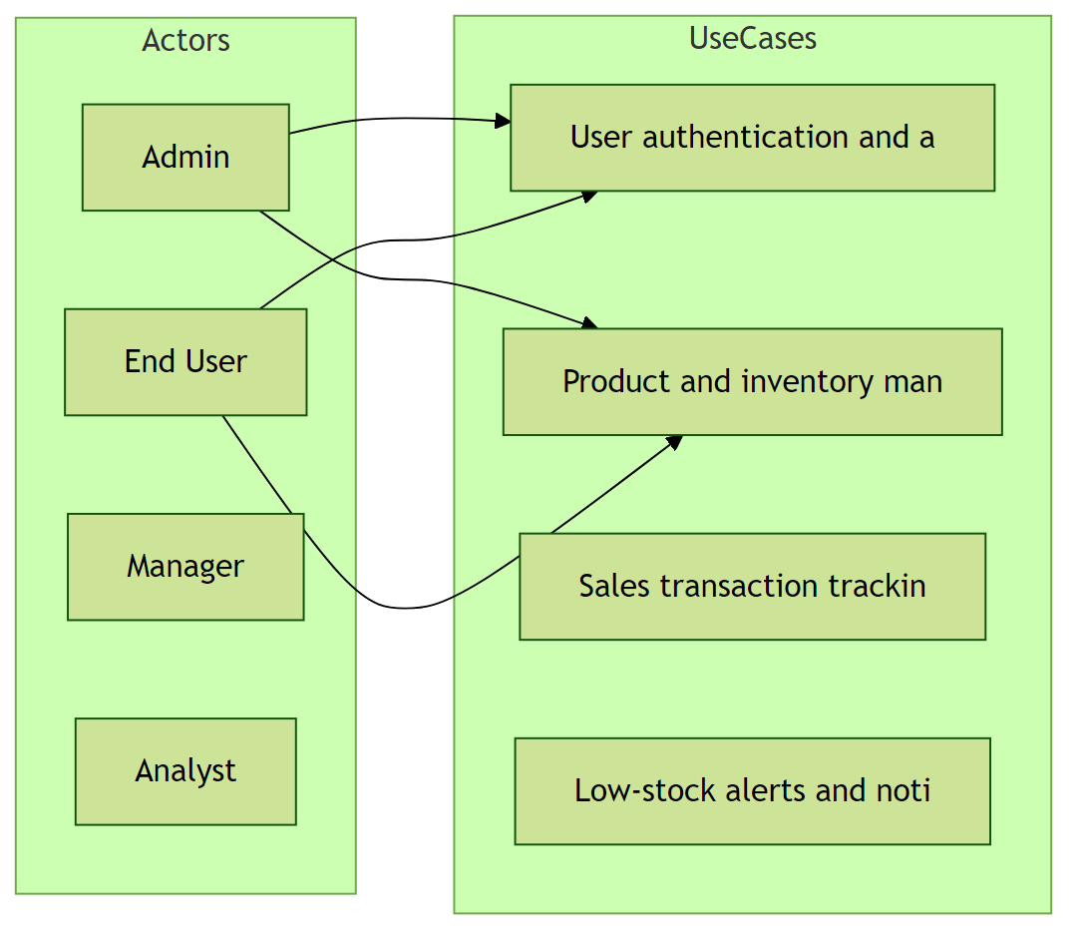

The Use Case Diagram representing functional interactions between users and the system has been added above.

4.1 User authentication and authorization
Description: User logs into the system → accesses role-based dashboard → adds or updates products → records sales transactions → system updates inventory automatically → user views reports and receives low-stock alerts → exports reports for analysis

Functional Requirements:
- Support: User authentication and authorization

4.2 Product and inventory management

Functional Requirements:
- Support: Product and inventory management

4.3 Sales transaction tracking

Functional Requirements:
- Support: Sales transaction tracking

4.4 Low-stock alerts and notifications

Functional Requirements:
- Support: Low-stock alerts and notifications

4.5 Supplier management

Functional Requirements:
- Support: Supplier management

4.6 Role-based dashboards

Functional Requirements:
- Support: Role-based dashboards

4.7 Daily

Functional Requirements:
- Support: Daily

4.8 weekly

Functional Requirements:
- Support: weekly

4.9 and monthly sales reports

Functional Requirements:
- Support: and monthly sales reports

4.10 Data export (CSV/PDF)

Functional Requirements:
- Support: Data export (CSV/PDF)

4.11 System settings and configuration

Functional Requirements:
- Support: System settings and configuration

5. User Workflow
The typical user workflow includes: User logs into the system; System validates credentials; User accesses role-based dashboard; User performs permitted actions; System processes and stores data; User views results or reports.
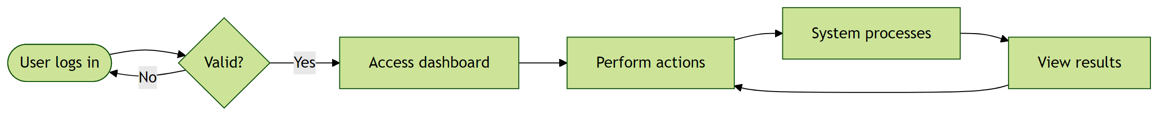

The User Flow / Workflow Diagram illustrating these steps has been included above.

6. Non-Functional Requirements

6.1 Performance
- Performance: Normal. Scale: 100-1k.
Rationale: User-specified.

6.2 Safety

6.3 Security
- Authentication required.
Rationale: Security.

6.4 Quality

7. Security Requirements
The system shall: Enforce secure authentication mechanisms; Use encrypted communication channels; Protect sensitive data from unauthorized access; Log security-related events.
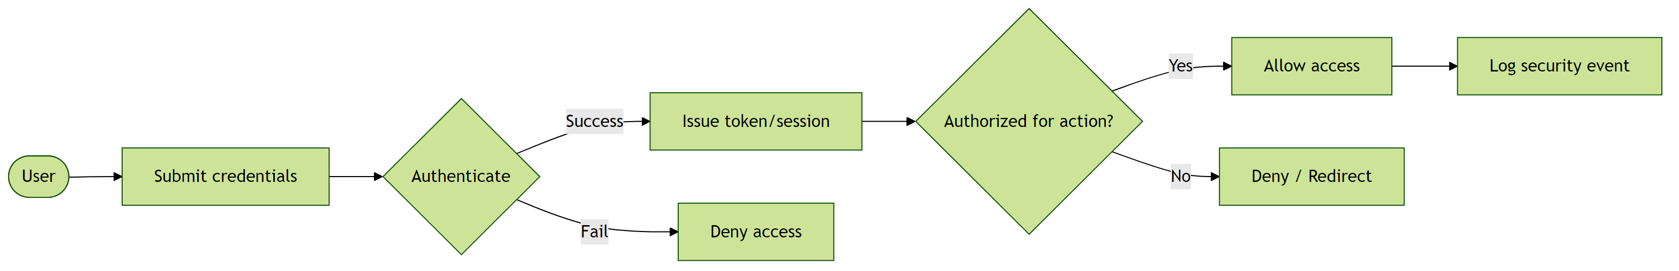

The Security Flow Diagram illustrating authentication and authorization has been included above.

8. Data Requirements
The system shall manage structured data entities and their relationships efficiently.
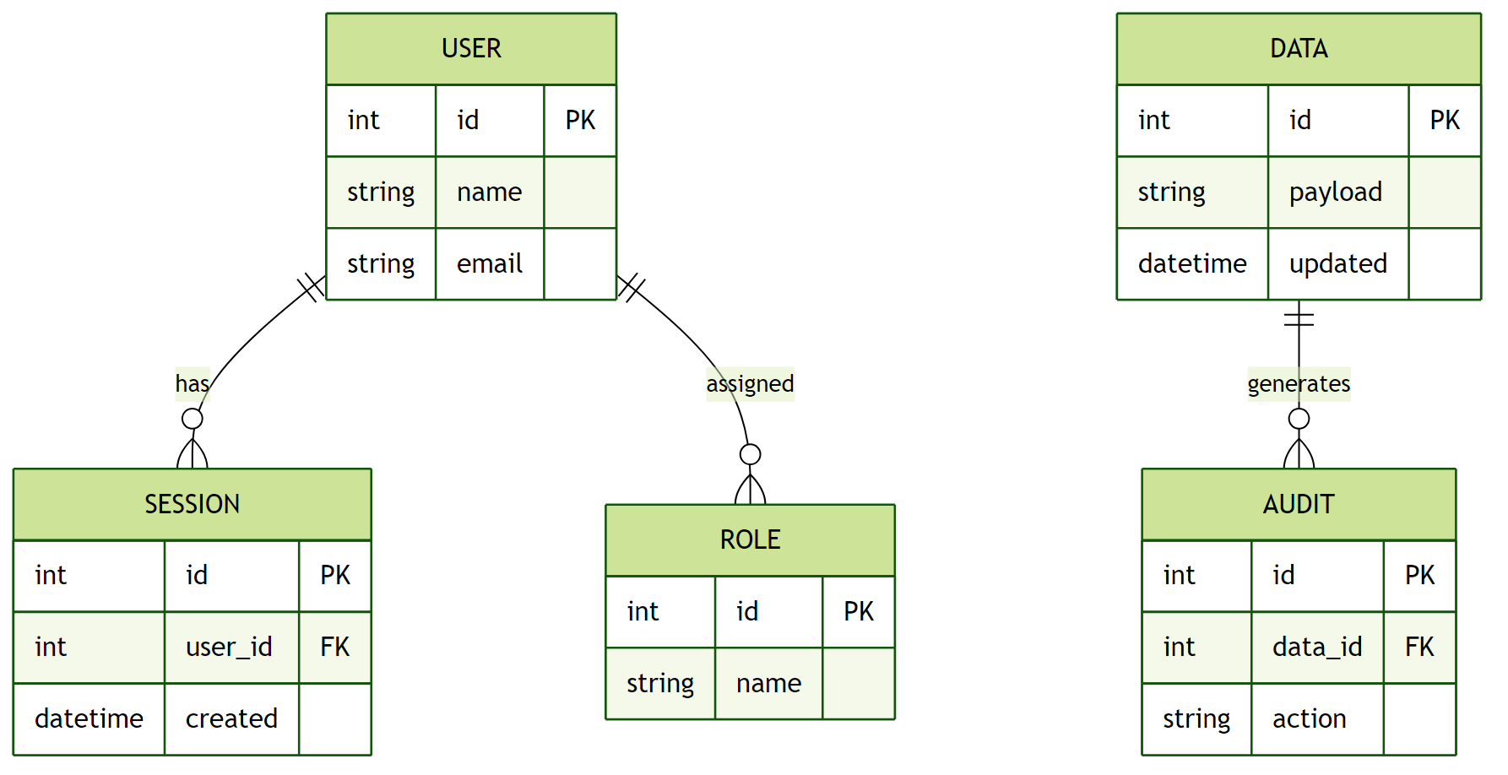

The Database / Entity Relationship Diagram (ERD) representing data structure and relationships has been included above.

9. External Interface Requirements

4.1 User Interfaces
Web or client UI as appropriate.

User Interface Architecture:
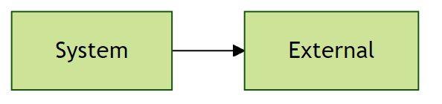

4.2 Hardware Interfaces
Standard hardware.

Hardware Interface Architecture:

Software / API architecture:
REST/API or as required.

10. Assumptions and Dependencies

Assumption 1:
Stakeholders have agreed on the problem statement and scope.
Impact: Scope clarity.

Assumption 2:
Target users: Admin, End User, Manager, Analyst.
Impact: Audience.

11. Future Enhancements
- Mobile application support
- Advanced analytics and insights
- Integration with additional third-party services

